8. Advanced Spectrum Management and Cognitive Radio Simulation

1. AIM
To simulate and analyze advanced spectrum management techniques in cognitive radio networks by detecting spectrum holes, performing dynamic spectrum allocation for multiple secondary users, and evaluating system performance in terms of throughput, interference, and spectrum utilization.

2. THEORY
2.1 Cognitive Radio (CR)
Cognitive Radio is an intelligent wireless system capable of sensing the radio spectrum, detecting unused frequency bands, and adapting its transmission parameters dynamically.
- Identifies free channels (spectrum holes).
- Avoids interfering with licensed Primary Users (PUs).
- Enables opportunistic communication by Secondary Users (SUs).
Used in: Dynamic Spectrum Access (DSA), 5G/6G, IoT, TV White Spaces.

2.2 Spectrum Sensing
Spectrum sensing allows CR devices to detect the presence or absence of PU activity.
Common sensing technique used: Energy Detection
- Measures energy of the received signal.
- Compares with a threshold to classify:
  - Below threshold → Spectrum Hole
  - Above threshold → PU occupied
- Simple, fast, and suitable for low-SNR environments.

2.3 Dynamic Spectrum Allocation (DSA)
Once free channels are detected, SUs dynamically select available channels.
Two main approaches:
- Centralized Allocation:
A controller assigns channels for maximum throughput and minimal interference.
- Random / Distributed Allocation:
Each SU selects a free channel independently.
DSA improves channel usage efficiency and reduces collisions.

2.4 Performance Metrics
To evaluate spectrum management effectiveness, the following metrics are analyzed:
- Throughput: Total data successfully transmitted by SUs.
- Interference: Number of collisions between SUs and PUs.
- Spectrum Utilization: Fraction of free channels used effectively.
- Detection Performance: Probability of detection (Pd) and false alarm (Pfa).
These metrics indicate how well CR adapts to spectrum variations and manages shared access.
3. SOFTWARE REQUIREMENTS
- MATLAB / MATLAB Online

4.PROCEDURE
A. Spectrum Sensing (Energy Detection) Procedure
- Initialize system parameters such as number of channels, SNR, noise power, and sensing duration.
- Generate noise-only samples to compute the detection threshold for a target false alarm probability.
- For each channel, collect received signal samples (noise or PU signal).
- Compute the signal energy and compare it with the threshold.
- Identify each channel as free (spectrum hole) or occupied.
- Record detection performance in terms of Pd (probability of detection) and Pfa (false alarm rate).

B. Dynamic Spectrum Allocation Procedure
- For every sensing cycle, obtain sensing results showing which channels are free.
- For each Secondary User (SU), determine the channels detected as available.
- Apply an allocation method:
  - Centralized Greedy Allocation → Pick channels giving maximum SU throughput.
  - Random Allocation → SUs randomly select from available channels.
- Assign one free channel per SU without violating PU protection rules.
- Simulate SU transmission on the allocated channels.
- Measure throughput, collisions, and how efficiently free channels are utilized.

C. Performance Analysis Procedure
- Run multiple time slots to simulate continuous PU/SU activity.
- For each slot, compute:
  - Total SU throughput
  - Number of interference events with PUs
  - Channel utilization ratio
- Average performance metrics over all slots for both centralized and random allocation schemes.
- Vary the number of SUs and repeat the simulation to observe trends.
- Plot throughput, interference, and spectrum utilization vs time or vs number of users.
- Compare which spectrum management approach provides better efficiency and lower interference.

6.PSEUDO CODE
Start
Set parameters: numChannels, numSUs, numSlots, samplesPerSlot, noisePower,
PU_occupancy_prob, target_Pfa, bandwidth.
Estimate energy detection threshold using noise-only trials.
For each time slot:
Generate PU activity for all channels.
// Spectrum sensing
For each SU and channel:
collect samples
energy = mean(samples^2)
mark channel free/occupied using threshold
End
// Dynamic spectrum allocation
Compute SNR per SU–channel.
Centralized: choose best (SU,ch) pairs for max throughput.
Random: each SU picks a random sensed-free channel.
// Throughput & interference
For each assignment:
if channel free: add throughput = BW*log2(1+SNR)
else: count interference events
End
Record throughput, interference, utilization.
End
Compute averages: throughput, interference, spectrum utilization.
Plot sensing results, throughput, interference, and utilization.
End

7.OUTPUTS

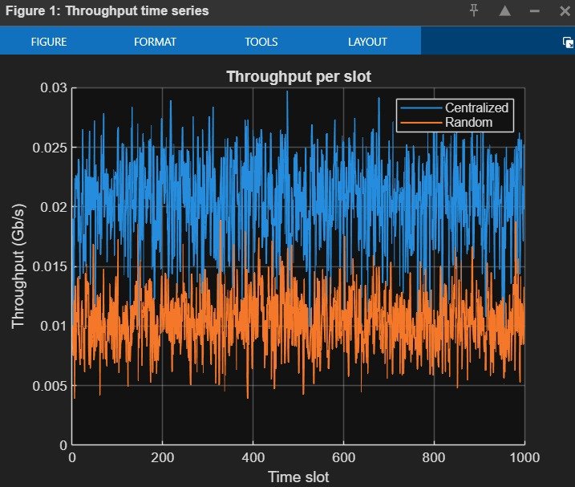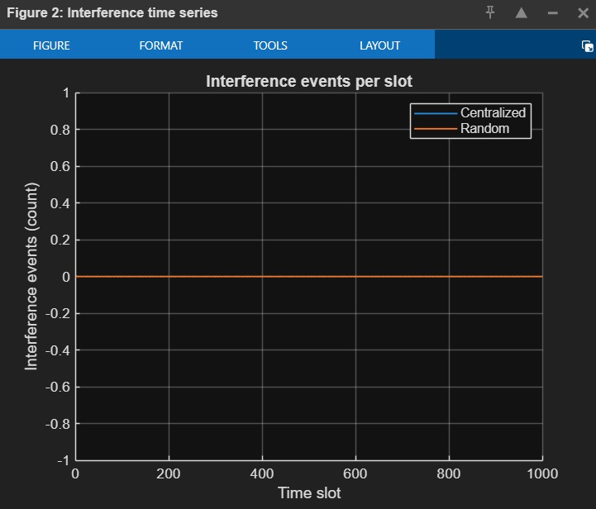
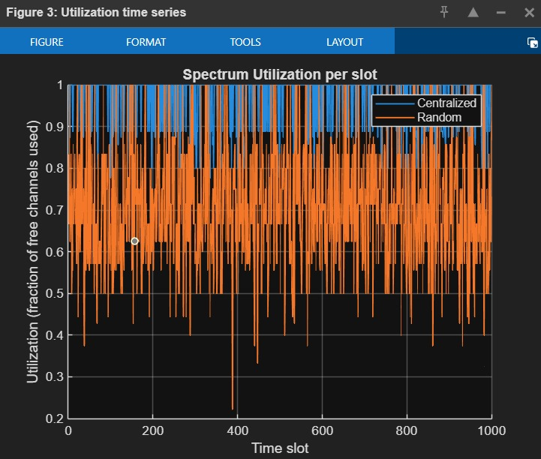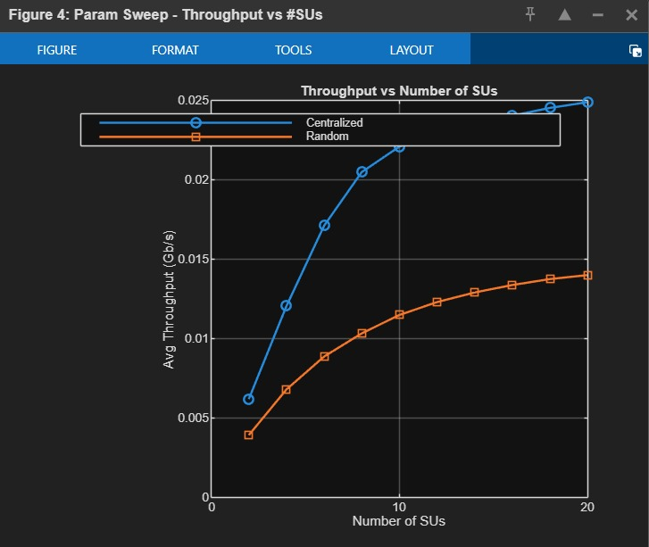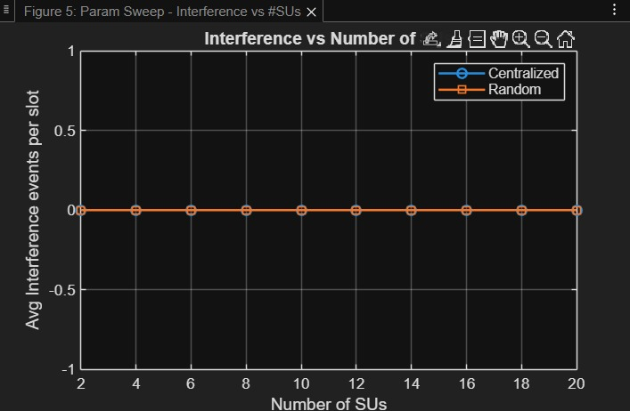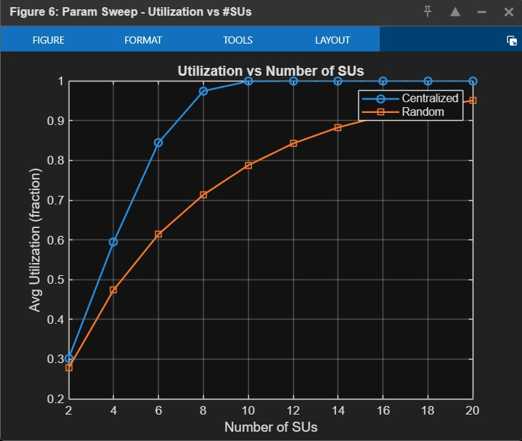
RESULT:
The cognitive radio simulation successfully detected spectrum holes, dynamically allocated channels to secondary users, and demonstrated improved throughput and spectrum utilization with reduced interference.

